**Manual Hospital Management System(HMS)**

**1 Taking care of HMS**

This product is more secretiveness data design

The following help you protect you HMS software

1 .keep mouse click in row data.

1. Do not only click the button with out mouse click.
2. Do not attempt to open the page with out permission.

Home page 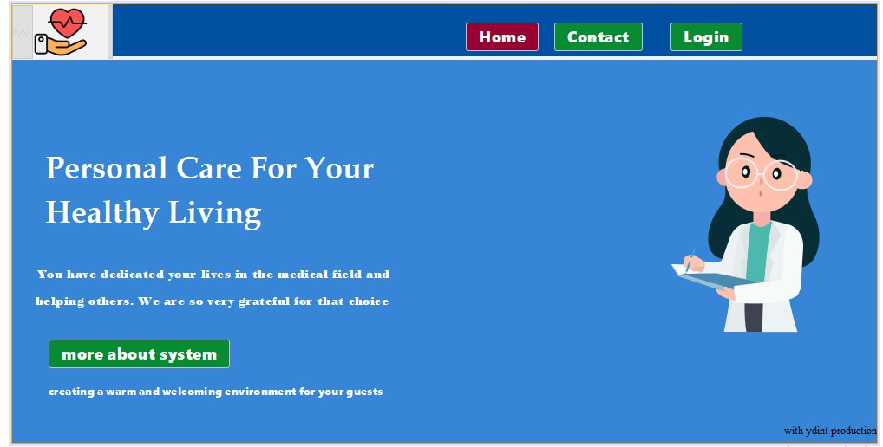

This is the home page tousers.

About page

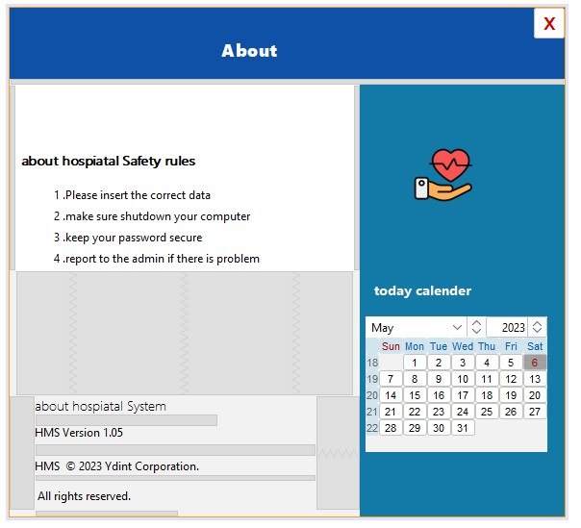

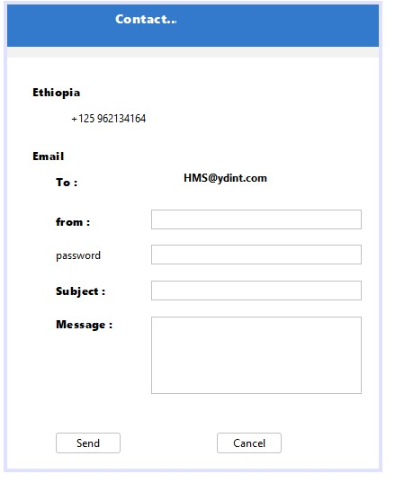

**Contact page you can contact if there is question.**

**If the user is login to Reception page they will meet this pages**

**Login page Reception**

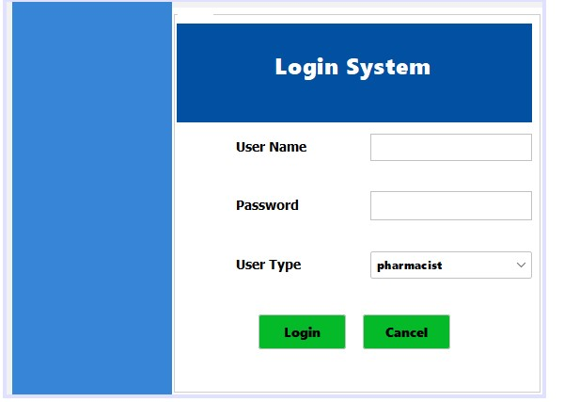

**They will login with appropriate name password and type example**

**User name ravi**

**password 123**

**type Reception**

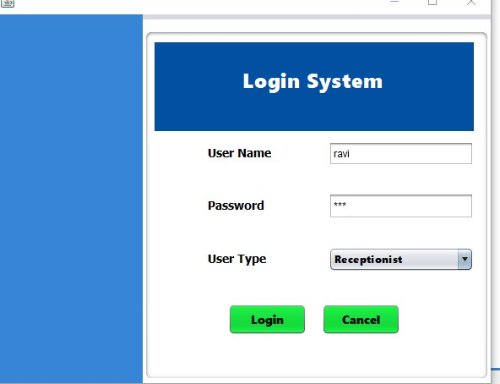 they login to system

Dash board page of Reception

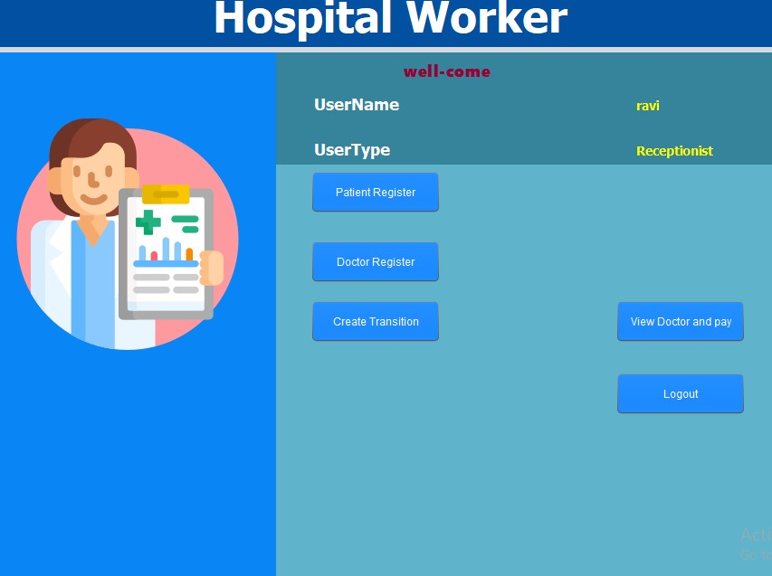

This is ravi dashboard they will click any they want.

Let patient register

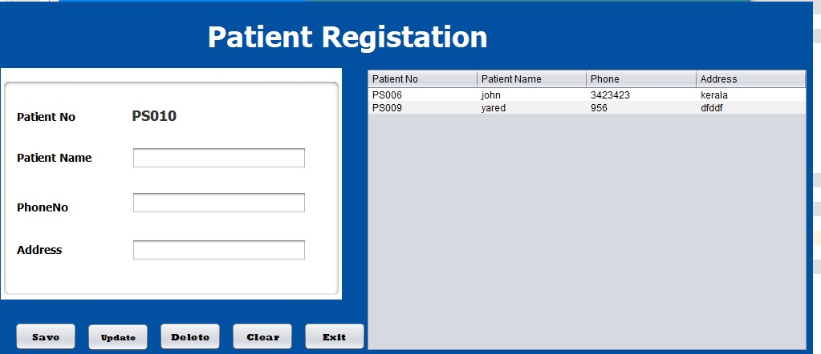

Let click doctor Register

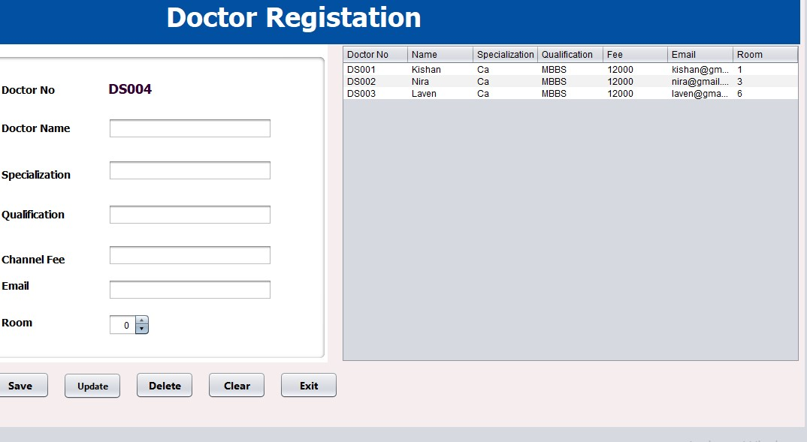

Let click view doctor and pay

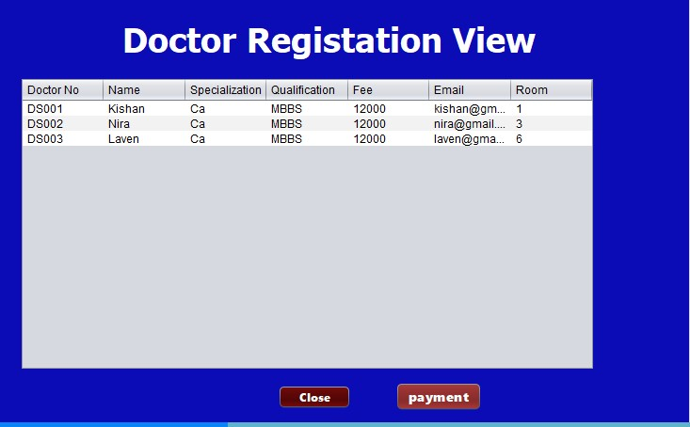

Let click doctor pay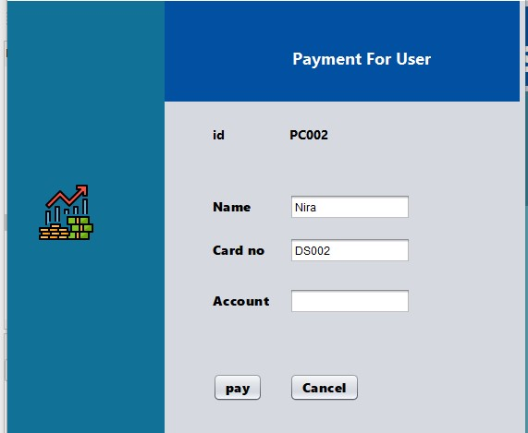

Let click placement of patient

You must click the row patient data otherwise you get error

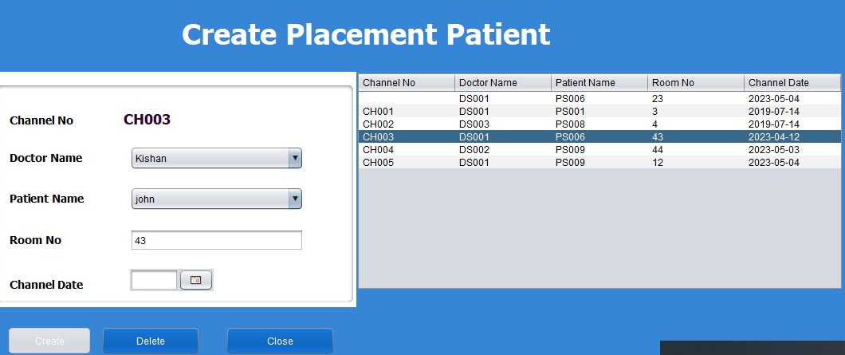

**If the user is login to Doctor page they will meet this pages**

**Login page Doctor**

**They will login with appropriate name password and type example**

**User name kishan**

**password 123**

**type Doctor**

Login page

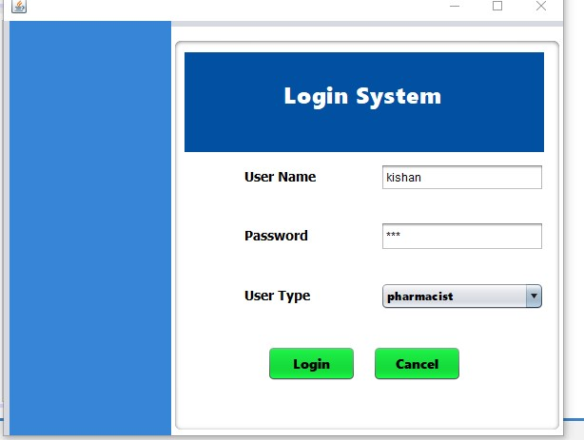

Now click to login and doctor dash board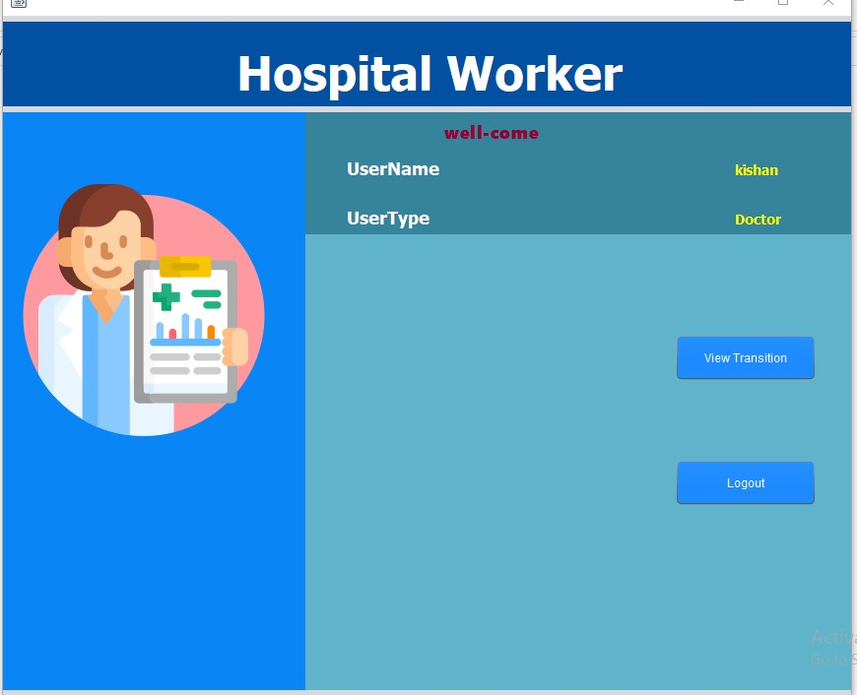

**Now click to view Transmission the patient**

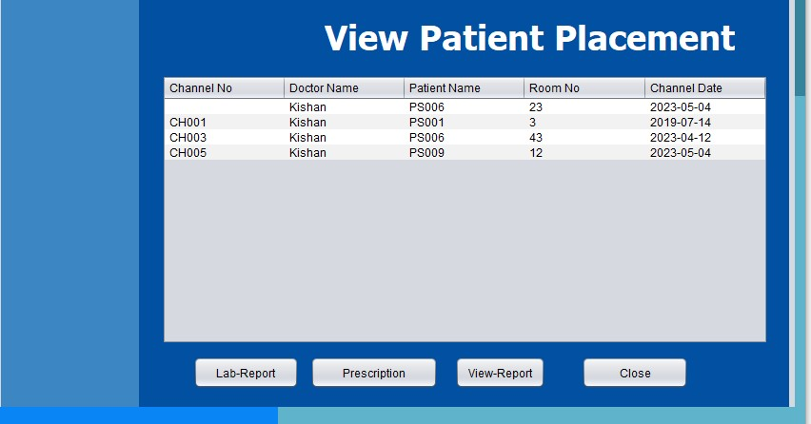

**Now click to view Transmission the patient and you have 3 page in this home**

**Click to Lab -Report to report to the laboratory**

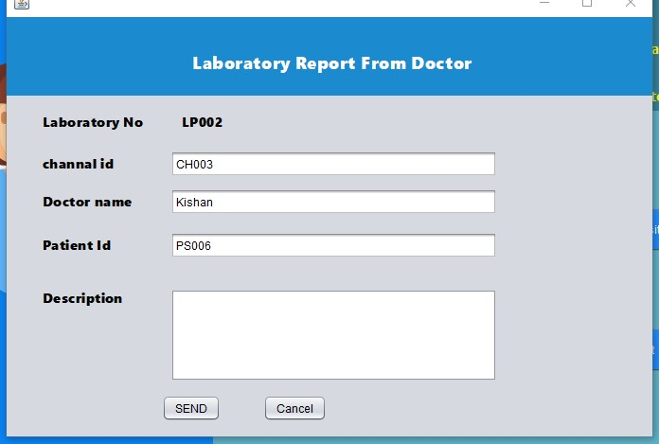

**After you send you can view lab-Report in Click to view-Report**

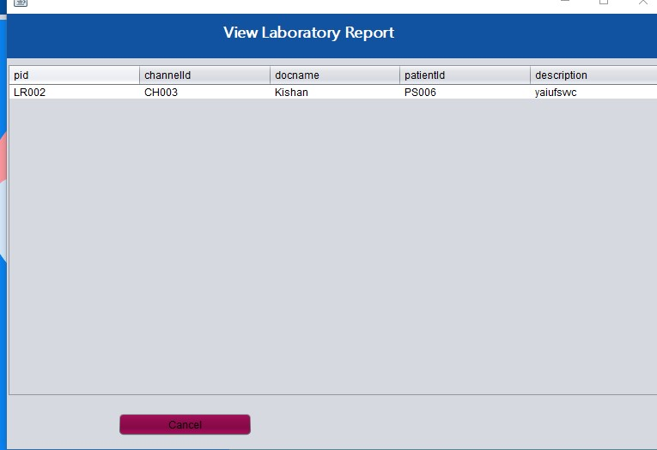

**Then you can Click prescription.report the medical to the pharmacy to patient.**

**But when you click prescription you must select the row of the data otherwise error.**

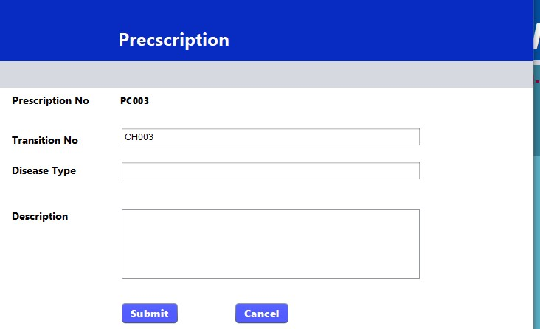

**If the user is login to Laboratory page they will meet this pages**

**Login page Laboratory**

**They will login with appropriate name password and type example**

**User name yared**

**password 123**

**type Laboratory**

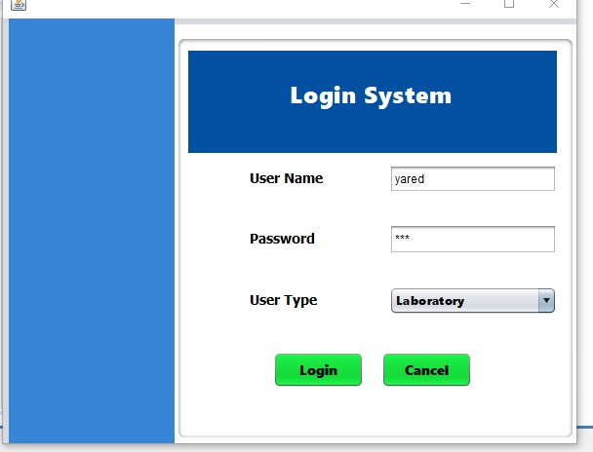

**Then login to dash board page of Laboratory**

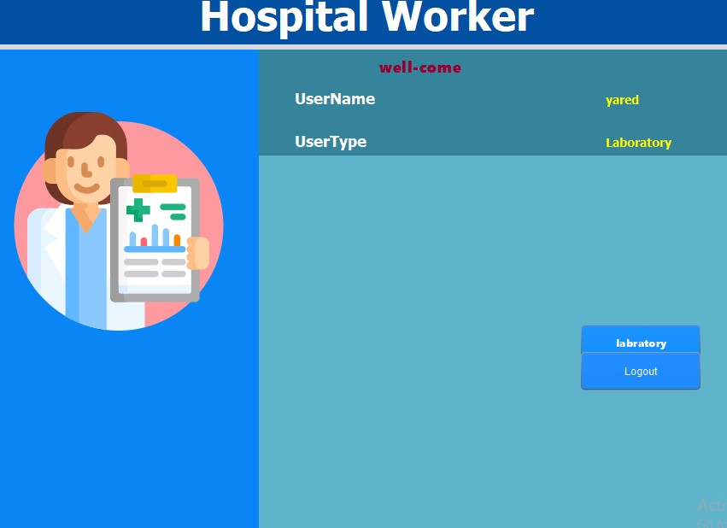

**The the laboratory doing teo thing.**

**See the data form doctor and send data to doctor.**

**Click laboratory**

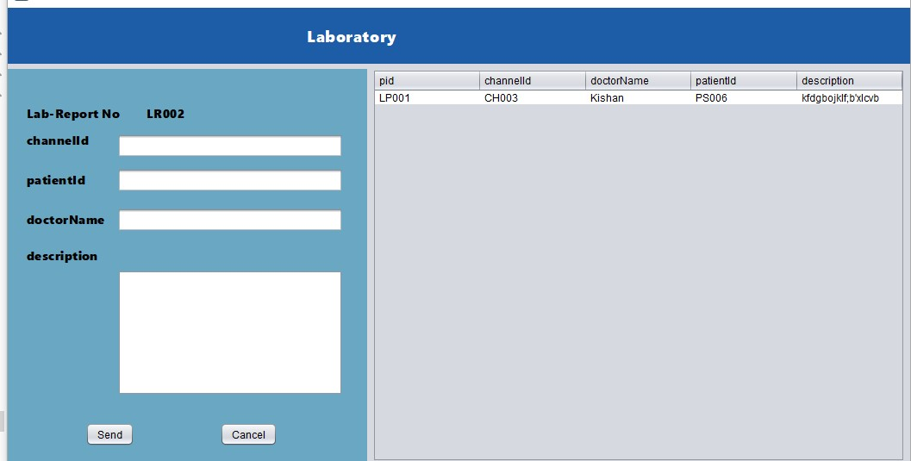

**In this page you must click the on data come from doctor other wise may error.**

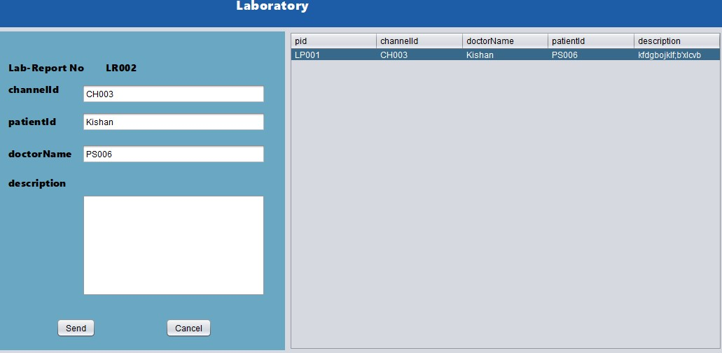

**If the user is login to Admin page they will meet this pages**

**Login page Admin**

**They will login with appropriate name password and type example**

**User name admin**

**password 123**

**type admin** 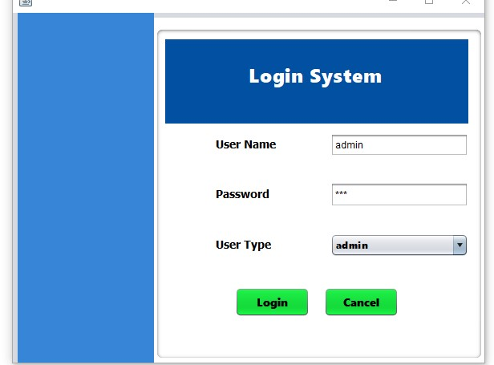

**The page the admin in this system the admin not working only view the page if the admin click the page with out knowing may error popup .**

**Dash board admin**

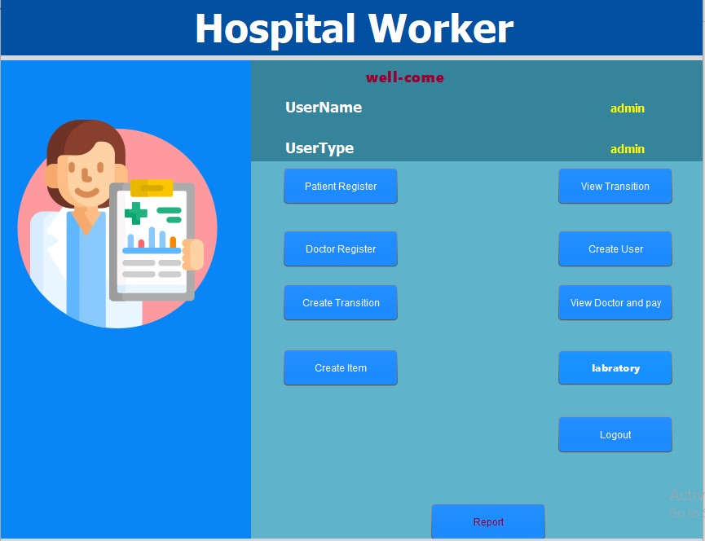

**The one thing admin do is view report.**

**If the user is login to Pharmacy page they will meet this pages**

**Login page Pharmacy**

**They will login with appropriate name password and type example**

**User name ab**

**password 123**

**Type Pharmacy**

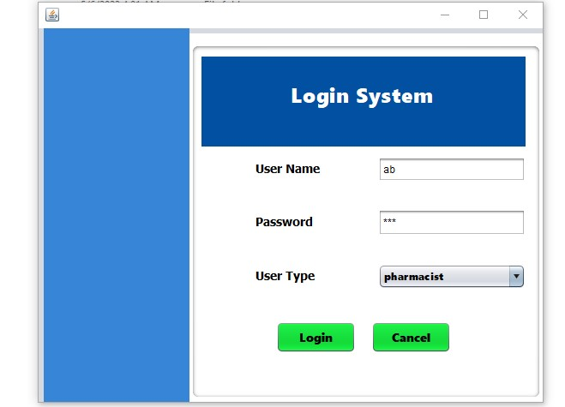

**Click and login to dashboard**

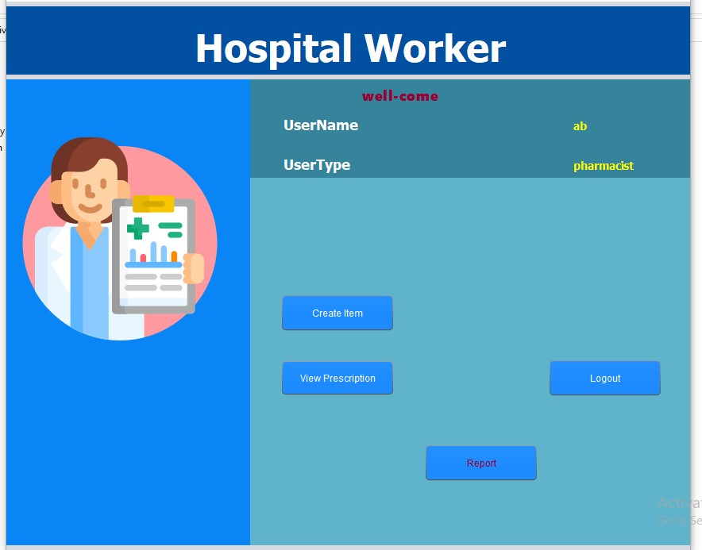

**Click on create item**

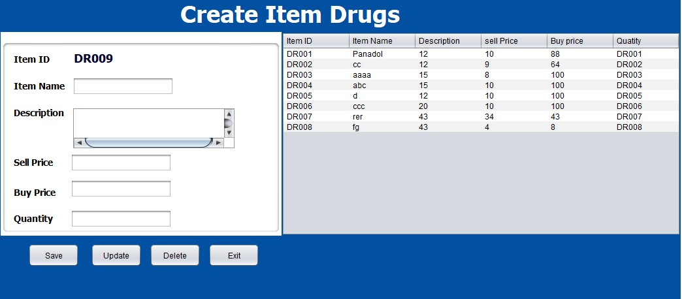

**Click view prescription**

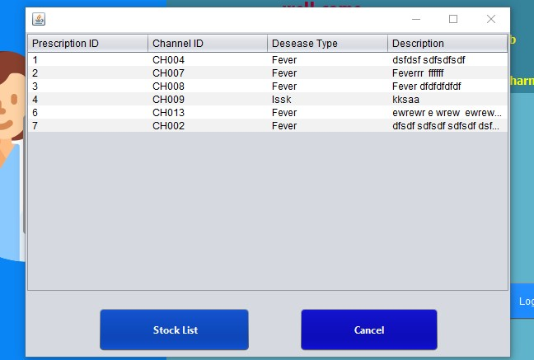

**Click stock list**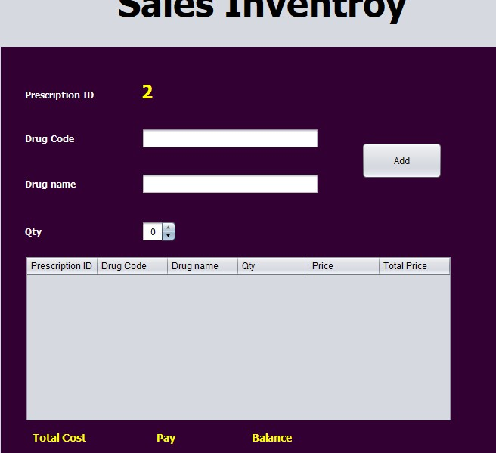

**This is some HMS Manual to user**